Complete Guide For Keyword Research

Keywords are the phrases used by any searchers/users to get particular information. As an SEO practice, we need to optimize our website in accordance with the user's search intent. Keyword Research is the only way of understanding the search intent of the user and helps in optimizing our web pages.

In simple words, keyword research helps us understand the audience what they exactly need. The content of the website must satisfy both the users and search engines. It is the basic thing to understand before starting the keyword research.

It is the basic thing to learn and work on when it comes to SEO practices. To bring your website well optimized for search intent, you can always get in touch with [SEO Services](https://the7eagles.com/search-engine-optimization/) Company

**Keyword Research Strategies**

Keyword research tools and strategies can be useful to uncover the information. It is used to build strong content.

It is used to help in business growth through search engine optimization

Before starting keyword research we must gather information like,

* Type of business and their goals
* Understand the Customers
* How customers reach the business
* How to increase the sales

Many people are using shortcuts because keyword research will take time.

So we just need a clear focus on what the audience actually wants.

From that keyword data we can get insights through that we can create a successful campaign that can be focused on arbitrary keywords.

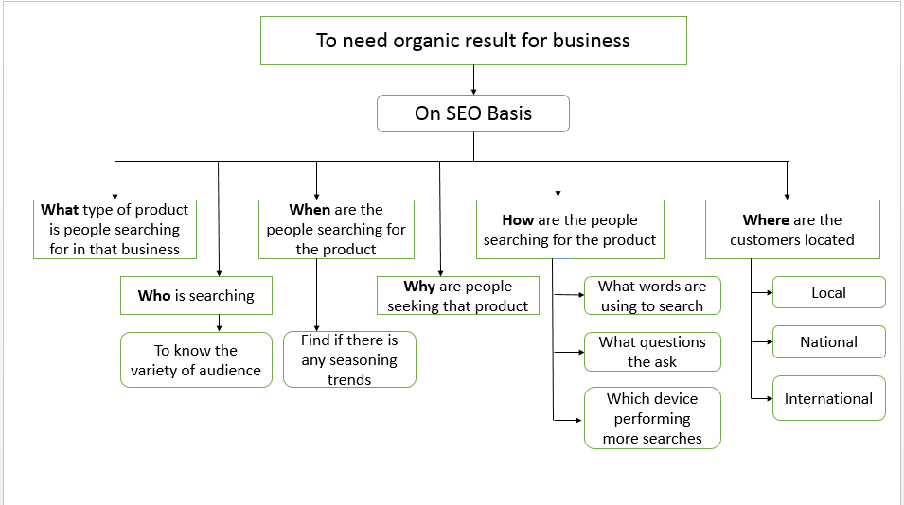

For Example,

Zaitoon Restaurant ( It is a hotel that contains North Indian, Chinese, Seafood and Arabian )

If SEO wants to grow this business and show up with organic results. First, we have to understand a little more who is using this restaurant so we might have to gather the information by asking some questions such as,

1.What type of hotels the customers are searching for?

* Veg
* Non-Veg
* Arabian
* Chinese

2.Who is searching for this business?

* Traveling persons/families
* Bachelors
* Working men/women
* Event Coordinator

3. When are people searching for restaurants?

* Some special occasions or events
* Traveling Time
* Holidays
* Festival Time

This business will work out in all kinds of seasons.

4.How are customers searching for the restaurant?

i) What are the words they use for search?

* Hotel near me
* Restaurants near me
* Best restaurants in Chennai
* Best veg/non-veg hotels near me
* Best hotels in Chennai
* Best hotels near me
* Can search hotels with the brand name also

Eg:  Zaitoon restaurant near me

ii) Which devices can be used more?

Most searches are performed on mobile devices.

5. Why are people seeking restaurants?

* For working people, they have no time to cook at that time they prefer a hotel.
* Relaxing with friends and families.
* Addict to the taste.
* For using washrooms while traveling also, because they seeking a hotel for safety.

6. What are the potential customers located?

* Local
* National
* International

**Discovering New Keyword ideas on Keyword Research**

Discovering new keywords based on ranking keywords, products, services. We can start over here. And enter those keywords in Keyword Research Tool that can be used to know search volume, difficulties.

We can also find the most popular variation of keywords among the searchers.

On this basis, we have to find the seed keyword and enter that in the keyword research tool from that we can get more keyword ideas.

For Example,

A photographer who specializes in weddings.

* First, in our mind, a seed keyword can be thought of as Wedding Photographer.
* If we put this keyword in the keyword research tool, we can get some other new keywords like Wedding photography, Average cost of wedding photographer, wedding photographer near me.

**Importance of Search Volume in Keyword Research:**

In this process, we can discover the relevant keywords which can be suitable for our content.

While discovering, we have to notice the search volume because it creates more advantages and that will be useful for ranking.

When we work on low search volume keywords we can prioritize our keywords because of less competition. While working on high competition search volume keywords it takes more time to rank.

The Higher Search Volume of keywords or keyword phrases that can require higher rankings and it will increase the keyword difficulty that will incorporate SERP features like featured snippets, knowledge graph, carousels.

These features are clogging up in the keyword result page that will increase the keyword difficulty.

Big brands like Amazon, Flipkart are often tapping the top 10 results with high search volume keywords.

To achieve organic ranking success we required higher search volume, Competition, and effort. The best suggestion is to work on low competition keywords and it is helpful to attain organic ranking quickly compared to higher competition keywords.

In any Keyword research tool, there will be an option to export the keyword ideas in the form of google sheets or excel sheets. From that, we can easily filter the moderate search volume keyword with less competition.

**Optimize the long tail keywords in Keyword Research:**

From the basic keyword research, we can get an idea to frame the longtail keyword.

Normal people are not searching with the exact keywords they have searching according to what they need, so search engines have to understand the intent of the audience.

For that purpose, SEO practices have also worked for long tail keywords. These keywords should be more than 4 words.

For Example,

“ Laptop “ - It is a common keyword that can give 500000 searches in a month or at least it will give 5000 searches per month. Because it is a popular search term that can be used frequently.

Mostly, when a keyword with high search volume shows that it’s not clearly understood. So there are chances to get irrelevant content the user doesn’t need.

For Example,

If users search for “biryani” but they need bamboo biryani, to order that biryani online or else to find that restaurant to take their family.

Google thinks that a searcher is interested in biryani so it will give different varieties of biryani in results.

If the user wants to find a bamboo biryani place for lunch. We can use another option like “Discover More places”. It is used to cover more SERP features.

The long-tail keyword can give specific and relevant results for searchers.

For Example,

A user searching for “cycle” - Google will produce the result with all types of cycle.

On the Other Hand, searching in another format like “ best cycle for kids 4-5 years”. Google will produce the exact results that a user needs.

**Keyword Research using Competitor Keywords**

When a keyword with high search volume is ranked from the competitor website. Take keywords already listed and ranked by competitors. So prioritize those keywords for ranking.

We can also use the competitor keyword that they are not currently using.

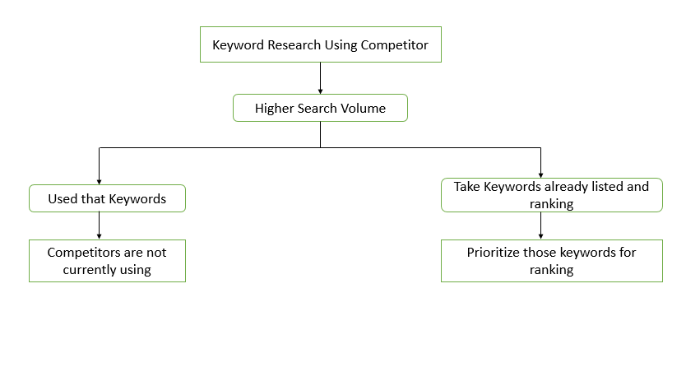

**Seasonal Keywords in Keyword Research**

We know seasonal trends like special occasions, festivals, etc. We have to create the content according to that. It will provide those settings in keyword research.

For Example,

“Valentine’s day”

The content can be prepared from Jan to Feb. In general, preparing content a month in advance. Because it will give a big reach around those months.

**Keyword Research by region:**

Before starting keyword research, we have to target a specific location, state, country, or specific town.

Some tools like Google Keyword Planner can evaluate interest by sub-region. Google Trends is used to compare keyword which would get more search volume and difficulty.

This is called Geo specific research which helps to give more relevant content to the target audience.

For Example,

If we find out a keyword “trainer”

In America, India like countries - a trainer is who giving training to people or animals like a gym trainer, a person who trains us to drive a car.

In England, Scotland, London like countries - a trainer means “tennis shoes” or “running shoes”.

From this example, we can see now Google is trying to give the result by the intent of users. So Google tries to give a format that can be the best suite for searcher’s intent.

**Types of Possible Search Keywords**

The major categories of possible search types are

* Informational Queries
* Navigational Queries
* Transactional Queries
* Commercial Investigation
* Local Queries

**Informational Queries**

When a searcher needs the information like name of the brand, and information about the particular places.

Eg.

Who build TajMahal

Emperor Shajahan

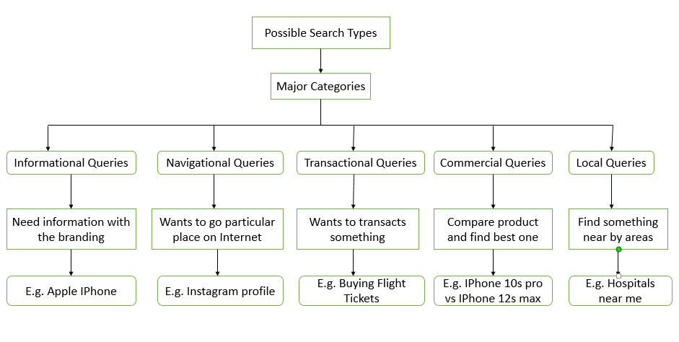

**Navigational Queries**

When a searcher wants to go to a particular place on the Internet like Facebook Home Page.

Eg:

Amazon blog

**Transactional Queries**

When a searcher wants to buy a plane ticket or listen to a song. Like these transaction-based queries is called transactional queries

Eg:

Buying Cinema ticket online

Online payment for ordering food

**Commercial Investigation**

When a searcher wants to compare the products and find the best one with the specific needs.

Eg

iPhone 10s VS iPhone 12s Max

**Local Queries**

When a searcher wants to find something locally like nearby shops etc

Eg

Hospitals near me

Google evaluates the searches to provide the most desired and relevant content for a particular keyword search.

When a query is not able to understand Google includes some “refine by” features to specify what they are exactly looking and the search engines provide better results for that to accomplish the task.

Google can be served upon the query. So get the focus keyword search it and look SERP results to understand what type of content need to create to attract both search engine and users.

**Keyword Research Tools**

The tools for determining the keyword research are an added advantage to SEO Services.

Some of the tools are listed below

* Moz Keyword Explorer
* Google Keyword Planner
* Google Trends
* Answer The Public(ATP)
* SpyFu Keyword Research Tool
* Uber Suggest
* Ahrefs

**Google Keyword Planner**

* It is a free tool and it is the best and most common tool for SEO Services in Keyword Research.
* It can be used to discover new keywords, and get keyword ideas from the seed keyword and the competitor website also.
* We can also extract the information through google sheets and excel sheet.
* Generally, we can get search volume, competition in all ranges.

**Moz Keyword Explorer**

* When a keyword is inserted in Keyword Explorer to get information like monthly search volumes and SERP features such as local packs, featured snippets.
* It will give accurate search volume data and also give live clickstream data.
* It will produce both keyword research metrics and complex analysis with less time and we can get the results in spreadsheets and it will be used to improve the website traffic.

**Google Trends**

* It is used to find the seasonal keyword fluctuations.
* It is also a free tool that can be used to compare the keywords and find the best one.
* It is a great tool for knowing the seasonal keyword.

For Example,

“Ramzan Costume ideas”

This keyword will be in the high range in the week before Ramzan.

**Answer The Public (ATP)**

* It is also a free tool which can be used to populate searches for questions around the specific keyword.
* It can visualize the search questions and can give suggestions to autocomplete the searches in an image format. And it is called a search cloud.
* We can also use this tool with another tool **Keyword Everywhere** and it will arrange the suggestions of Answer the public tool according to search volume.

**SpyFu Keyword Research Tool**

* It can also provide keyword ideas and competitor keyword data.
* It will be in domain Search and provide the monitoring tools

**Uber Suggest**

* It is also an SEO tool that can be used for getting new keyword ideas, search volume, etc.
* It can provide a certain range of information for free and then we have to subscribe to get more information.

**Ahrefs**

* It is also used to conduct keyword research for Google, YouTube, Amazon, etc.
* It is paid tool but it gives exact and more information compare to other tools

**Conclusion**

* Keyword research is helping SEO Services to grow the business on the basis of manual keyword search, and research using tools.
* This manual research can be done as per the user’s intent. An SEO person has to think like a customer and ask questions about business related to themselves.
* By using [free SEO tools](https://the7eagles.com/top-5-free-seo-tools/), we can get new keyword ideas, search volume, competition, and also get the ranking of competitor keywords from their site.
* From there we can get our keyword idea to get rank in SERP.

All these processes are done to reach the target audience and to get more business and more traffic.